TASK -1

Familiar with Git commands like git init, git status, git add, git commit, git push, and git pull.

Step 1- Download Git Bash in your PC’s

Step- 2- Download Notepad in your PC’s

Step 3- After downloading Github bash

**Run this command** -

**git config –global user.name ”Sanskriti Gupta”**

**git config –global user.email** [**sanskritigupta2101@gmail.com**](mailto:sanskritigupta2101@gmail.com)

**git config –global -l**

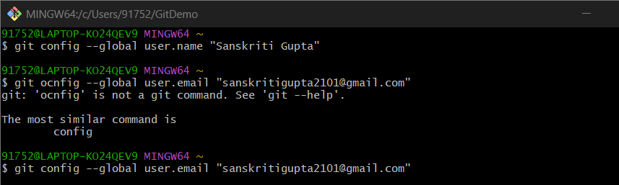

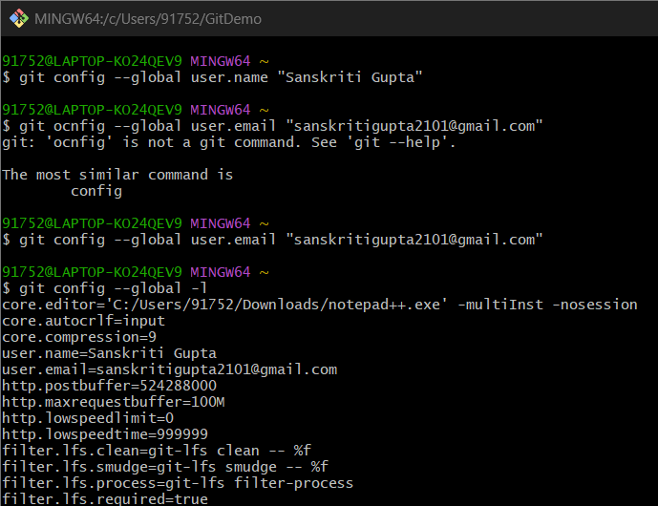

Step 4- Connect it with Notepad++

Run this command

Git config –global core.editor “\”C:/Program Files/Notepad++/notepad++.exe\" -multiInst -nosession"

git config --global -e



**Step -5 Create Local Git Repository and Commit a File**

**Run the commands**

**Mkdir GitDemo**

**Cd GitDemo**

**Git init**

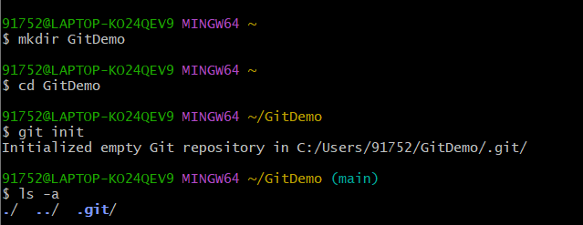

**Step -6 Create file and add content**

**Echo “Welcome to Git hands-on lab”> welcome.txt**

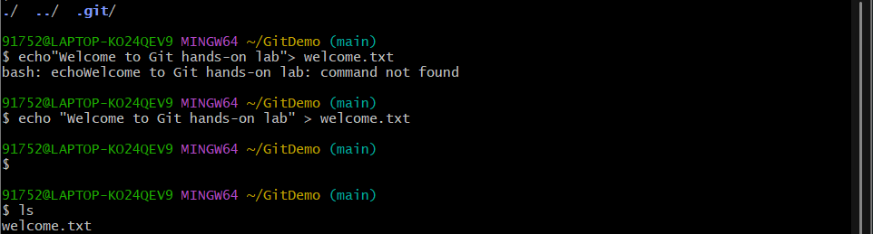

**Step-7 Verify the file was created**

**Ls**

**Step 8- Check the contents of the file**

**Cat welcome.txt**

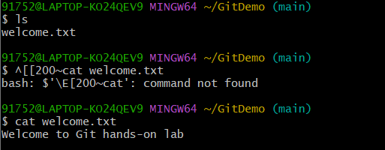

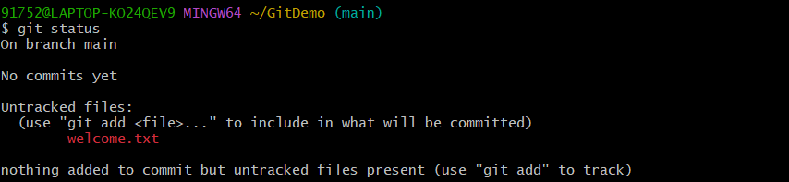

**Step -9- Add the file to the staging area**

**git add welcome.txt**

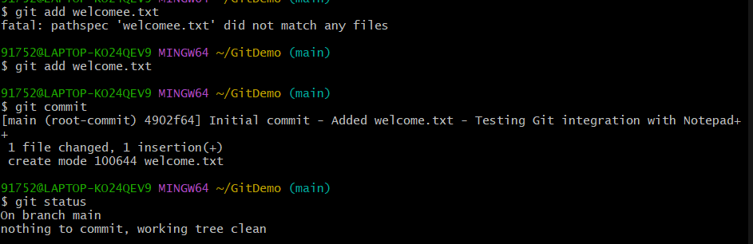

**Step -10 git commit**

**Step 11: git status**